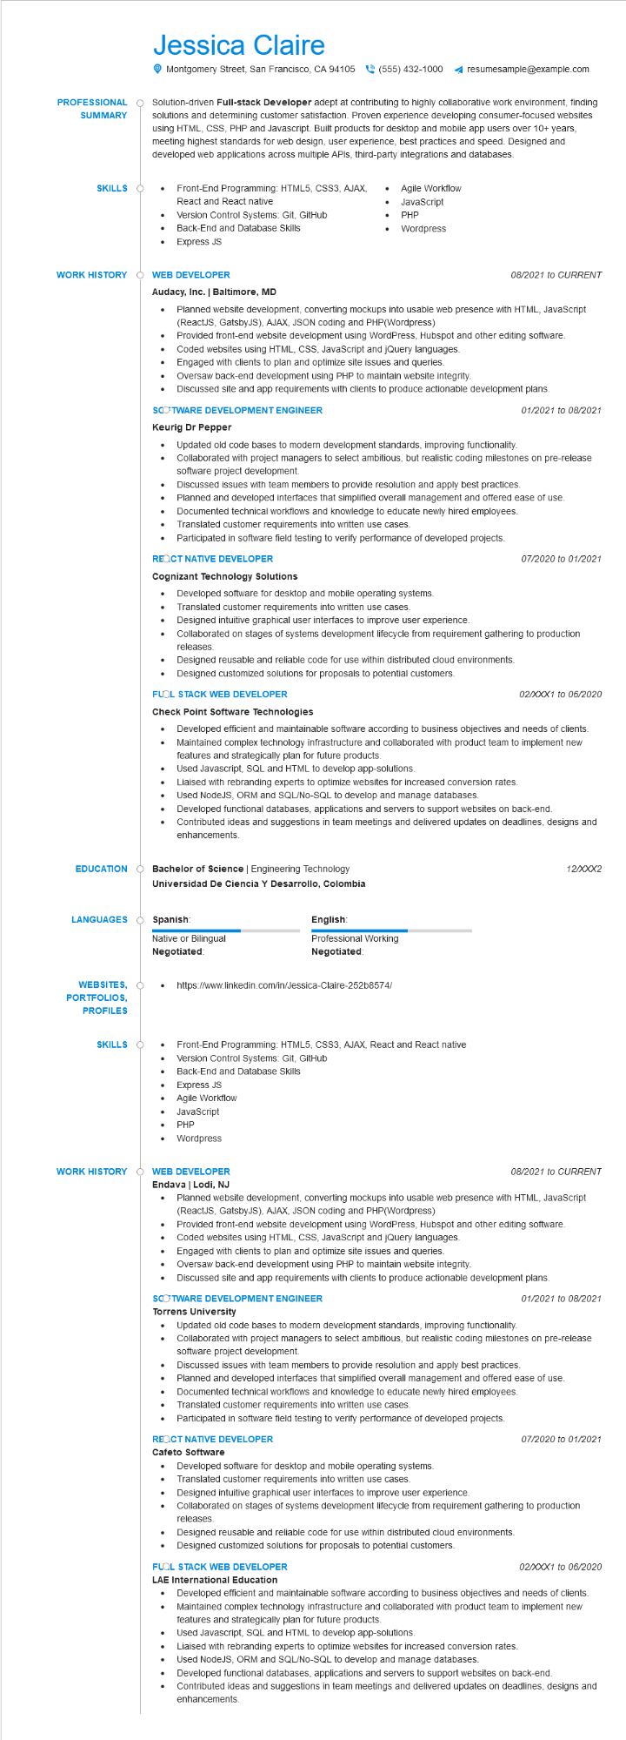
PROFESSIONAL
SUMMARY
Jessica Claire
Montgomery Street, San Francisco, CA 94105(555) 432-1000
resumesample@example.com
Solution-driven Full-stack Developer adept at contributing to highly collaborative work environment, finding solutions and determining customer satisfaction. Proven experience developing consumer-focused websites using HTML, CSS, PHP and Javascript. Built products for desktop and mobile app users over 10+ years, meeting highest standards for web design, user experience, best practices and speed. Designed and developed web applications across multiple APIs, third-party integrations and databases.
Front-End Programming: HTML5, CSS3, AJAX,
SKILLS
•
React and React native
Version Control Systems: Git, GitHub
Back-End and Database Skills
·
Express JS
Agile Workflow JavaScript
•
PHP
•
Wordpress
WORK HISTORY
WEB DEVELOPER
Audacy, Inc. | Baltimore, MD
•
08/2021 to CURRENT
Planned website development, converting mockups into usable web presence with HTML, JavaScript (ReactJS, GatsbyJS), AJAX, JSON coding and PHP(Wordpress)
Provided front-end website development using WordPress, Hubspot and other editing software. Coded websites using HTML, CSS, JavaScript and jQuery languages.
•
Engaged with clients to plan and optimize site issues and queries.
•
Oversaw back-end development using PHP to maintain website integrity.
Discussed site and app requirements with clients to produce actionable development plans.
SCOTWARE DEVELOPMENT ENGINEER
Keurig Dr Pepper
•
•
01/2021 to 08/2021
Updated old code bases to modern development standards, improving functionality. Collaborated with project managers to select ambitious, but realistic coding milestones on pre-release software project development.
Discussed issues with team members to provide resolution and apply best practices.
Planned and developed interfaces that simplified overall management and offered ease of use.
Documented technical workflows and knowledge to educate newly hired employees.
•
Translated customer requirements into written use cases.
·
Participated in software field testing to verify performance of developed projects.
07/2020 to 01/2021
REQCT NATIVE DEVELOPER
Cognizant Technology Solutions
•
Developed software for desktop and mobile operating systems.
Translated customer requirements into written use cases.
Designed intuitive graphical user interfaces to improve user experience.
Collaborated on stages of systems development lifecycle from requirement gathering to production releases.
• Designed reusable and reliable code for use within distributed cloud environments.
• Designed customized solutions for proposals to potential customers.
FLOL STACK WEB DEVELOPER
Check Point Software Technologies
02/XXX1 to 06/2020
• Developed efficient and maintainable software according to business objectives and needs of clients. Maintained complex technology infrastructure and collaborated with product team to implement new features and strategically plan for future products.
Used Javascript, SQL and HTML to develop app-solutions.
Liaised with rebranding experts to optimize websites for increased conversion rates.
Used NodeJS, ORM and SQL/No-SQL to develop and manage databases.
•
Developed functional databases, applications and servers to support websites on back-end.
•
Contributed ideas and suggestions in team meetings and delivered updates on deadlines, designs and enhancements.
EDUCATION
Bachelor of Science | Engineering Technology
LANGUAGES
WEBSITES, Ò
PORTFOLIOS,
PROFILES
Universidad De Ciencia y Desarrollo, Colombia
Spanish:
Native or Bilingual Negotiated:
•
SKILLS O
•
English:
Professional Working Negotiated:
https://www.linkedin.com/in/Jessica-Claire-252b8574/
Front-End Programming: HTML5, CSS3, AJAX, React and React native
Version Control Systems: Git, GitHub
• Back-End and Database Skills
•
Express JS
Agile Workflow
•
JavaScript
PHP
•
Wordpress
WORK HISTORY
WEB DEVELOPER
12/XXX2
08/2021 to CURRENT
Endava | Lodi, NJ
•
Planned website development, converting mockups into usable web presence with HTML, JavaScript (ReactJS, GatsbyJS), AJAX, JSON coding and PHP(Wordpress)
Provided front-end website development using WordPress, Hubspot and other editing software. Coded websites using HTML, CSS, JavaScript and jQuery languages.
Engaged with clients to plan and optimize site issues and queries.
Oversaw back-end development using PHP to maintain website integrity.
Discussed site and app requirements with clients to produce actionable development plans.
SCOTWARE DEVELOPMENT ENGINEER
Torrens University
01/2021 to 08/2021
• Updated old code bases to modern development standards, improving functionality. Collaborated with project managers to select ambitious, but realistic coding milestones on pre-release software project development.
Discussed issues with team members to provide resolution and apply best practices.
Planned and developed interfaces that simplified overall management and offered ease of use.
Documented technical workflows and knowledge to educate newly hired employees.
•
Translated customer requirements into written use cases.
• Participated in software field testing to verify performance of developed projects.
REQCT NATIVE DEVELOPER
Cafeto Software
Developed software for desktop and mobile operating systems.
Translated customer requirements into written use cases.
Designed intuitive graphical user interfaces to improve user experience.
07/2020 to 01/2021
Collaborated on stages of systems development lifecycle from requirement gathering to production
releases.
•
Designed reusable and reliable code for use within distributed cloud environments.
• Designed customized solutions for proposals to potential customers.
FLOL STACK WEB DEVELOPER
LAE International Education
02/XXX1 to 06/2020
Developed efficient and maintainable software according to business objectives and needs of clients. Maintained complex technology infrastructure and collaborated with product team to implement new features and strategically plan for future products.
•
Used Javascript, SQL and HTML to develop app-solutions.
Liaised with rebranding experts to optimize websites for increased conversion rates.
Used NodeJS, ORM and SQL/No-SQL to develop and manage databases.
Developed functional databases, applications and servers to support websites on back-end.
Contributed ideas and suggestions in team meetings and delivered updates on deadlines, designs and enhancements.

